Building Web Applications with EclipseRT
Virgo Tutorial Guide
This guide shows you all the steps in the Virgo section of the tutorial.
Table of Contents
A.Get set up 2
B.Deploy a web app 4
C.Explore a web app using the admin console 6
D.Explore a web app using JMX 8
E.Configure application trace 9
F.Configure Tomcat 10
G.Configure a specific context 11
H.Further information 12

Get set up
- You'll need Java 6. If you don't have it, please try downloading it. If you can't get it, follow the instructions in this guide some other time.
- Get one of the memory sticks being passed around. Unless you're looking at someone else's display, you already have it. If you still have a memory stick at the end of the tutorial, you are welcome to keep it.
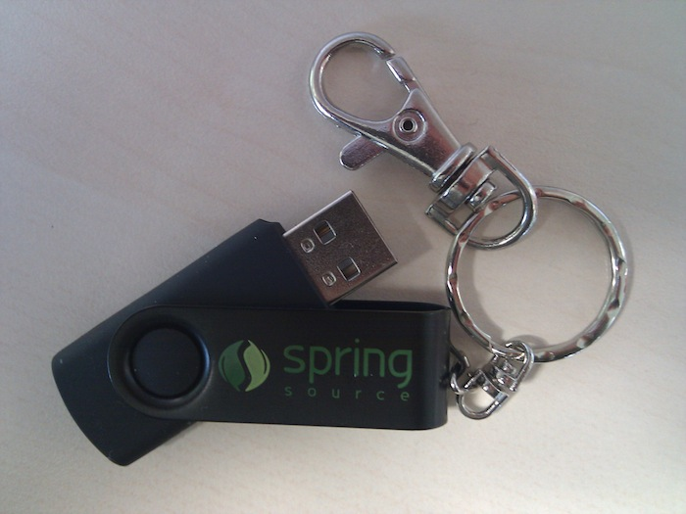
- Copy everything (except any directories with names beginning with “.”) from the memory stick to your computer.
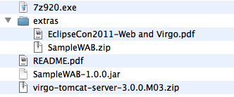
This includes:
  - 7z920.exe – 7zip extractor for Windows users (see step 4).
  - README.pdf – this guide
  - SampleWAB-1.0.0.jar – the sample web app
  - virgo-tomcat-server-3.0.0.M03.zip – the latest and greatest milestone of Virgo Tomcat Server, including documentation.
  - extras directory – this contains some SDKs that will be used in the non-Virgo sections of the tutorial and, for completeness, the few slides for the Virgo section and the source of the sample web app.
- Unzip the virgo-tomcat-server file
Avoid spaces in the directory path you unzip to.
Windows Users: use the 7zip extractor provided on the memory stick rather than the built in zip extractor.
Windows Users: Due to problems with long file paths on Windows, unzip virgo-tomcat-server at a root of a drive, e.g. in C:\.
- Starting the virgo-tomcat-server

Use a terminal window, change directory to the unzipped virgo-tomcat-server, change directory to the bin subdirectory, and then...

For Unix/Linux/Mac

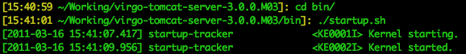
For Windows
- User region ready

As Virgo starts up various messages will go by announcing what is happening. The first one to notice is 'Kernel Started', this mean the Virgo kernel is up and it will now start up the user region. The next one to note is 'User region ready'. This means Virgo has started including any user defined artifacts to be started in the user region.

At this point Virgo will start looking for applications to deploy and there are some already available and the messages that follow are these applications being deployed.

Deploy a web app

- Deploy using the pickup directory
Copy the sample web application to the pickup directory within the virgo-tomcat-server.
You should see similar output to indicate the application has been deployed.
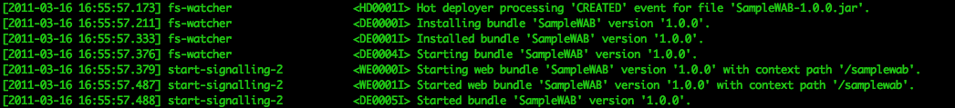
- Undeploy using the pickup directory
Simply remove the sample application from the pickup directory.
You should see similar output to indicate the application has been undeployed.
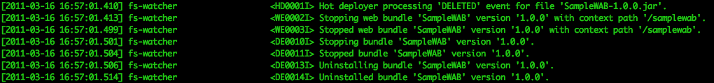
- The Splash screen app
You may have noticed some other applications in the pickup directory already including the splash and admin screens. Open your favourite browser and go to http://localhost:8080
The splash screen shows you the version of Virgo you are running and provides a link to another application in the pickup directory: the Admin Console. Click it! You will require an id and password, the defaults are 'admin' and 'springsource'.
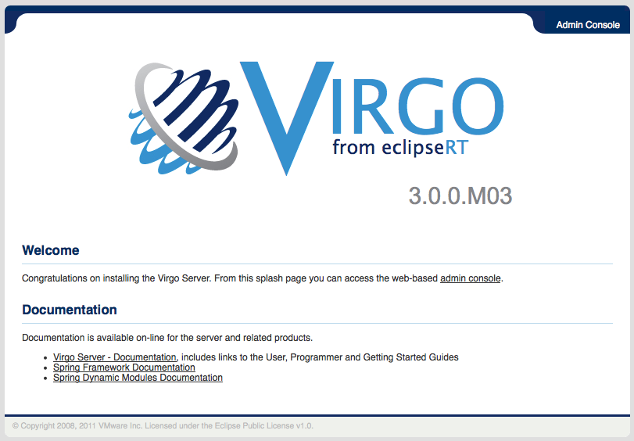Illustration 1: Splash Screen

- Deploy using the Admin console
Click on the "Artifacts" tab on the far left. Then select the sample application jar file by clicking “Browse...”, “Choose file...”, or similar, depending on your browser, and then click “Upload”.
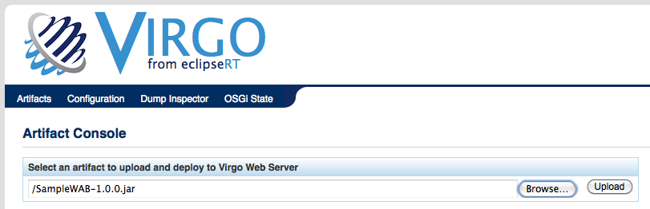

Explore a web app using the admin console
- Open the admin console at http://localhost:8080/admin
- Click on "Artifacts"
- Expand the "+" sign next to "bundles"
- Expand the "+" sign next to "SampleWAB: 1.0.0"
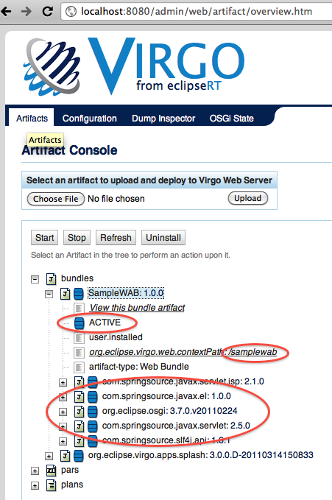
- Observe the state of the web app, its context path, and its dependencies
- Now click on the link “View this bundle artifact”
- Expand the “Published Services” section
- Observe the ServletContext service published in the service registry (the service id you see will probably not be 201):
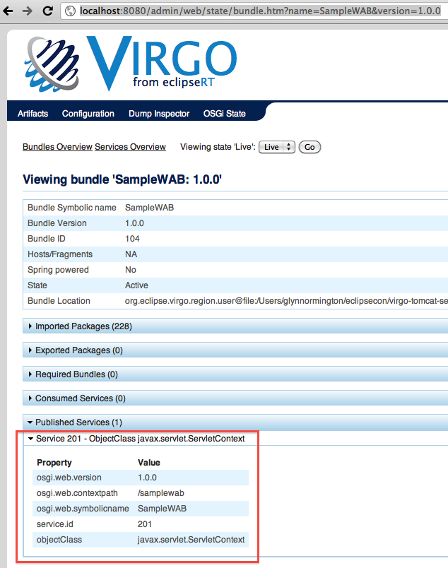
- Exercise: Go back to the artifacts view and try stopping the sample web app and see what difference this makes in the artifacts view and when viewing the bundle artifact.

Explore a web app using JMX
- Run jconsole from a terminal window
- Connect to the org.eclipse.virgo.osgi.launcher.Launcher process
- Select the Mbeans view.
- Navigate through org.eclipse.virgo.kernel->Model->bundle->SampleWAB
- Observe the state of the web app, its context path, and its dependencies. Note: to display the value field of attributes such as Dependents, double-click the Value field. Double-click again to close the view.
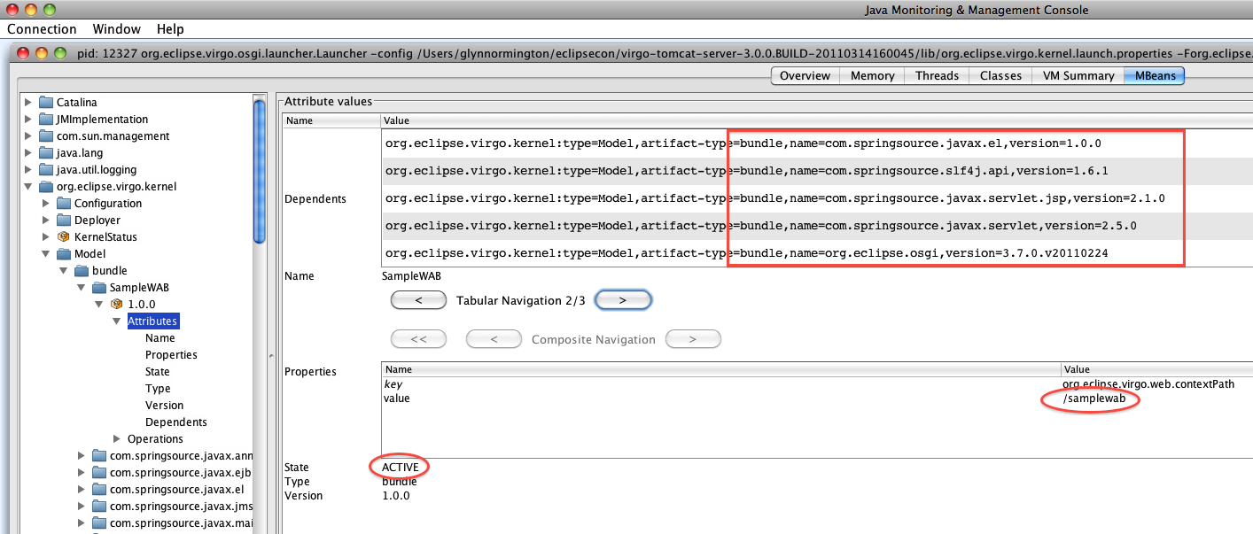

Configure application trace
- Copy and paste the following to config/serviceability.xml as a child of the <configuration> element:
<logger level="DEBUG" additivity="false" name="sample">
<appender-ref ref="SIFTED_LOG_FILE" />
<appender-ref ref="LOG_FILE" />
</logger>

- Restart Virgo: the admin console does allow you to do this , so type Ctrl-C in the terminal in which Virgo is running and then start it again
- Drive the sample web app at http://localhost:8080/samplewab/
- A new directory serviceability/logs/SampleWAB-1.0.0 will have been created. Look in serviceability/logs/SampleWAB-1.0.0/log.log to see debug logging output:

[2011...] http-8080-5 sample.SampleServlet enter SampleServlet.doGet
[2011...] http-8080-5 sample.SampleServlet exit SampleServlet.doGet

Configure Tomcat
- Edit config/tomcat-server.xml
- For example, add the following request dumper valve configuration as a child of the <Engine> element:
<Valve className="org.apache.catalina.valves.RequestDumperValve"/>
- Restart Virgo the admin console does allow you to do this , so type Ctrl-C in the terminal in which Virgo is running and then start it again
- Drive the sample web app at http://localhost:8080/samplewab/
- Look in serviceability/logs/virgo-server/log.log to see requests and responses:
[2011...] http-8080-1 System.err ... o.a.c.valves.RequestDumperValve invoke
[2011...] http-8080-1 System.err INFO: REQUEST URI=/samplewab/
[2011...] http-8080-1 System.err ... o.a.c.valves.RequestDumperValve invoke
[2011...] http-8080-1 System.err INFO: authType=null
etc.

Configure a specific context
- Remove the request dumper valve from config/tomcat-server.xml
- Create a directory config/Catalina/localhost
- Create a file in that directory called “samplewab.xml” with the following contents:
<Context>
<Valve className="org.apache.catalina.valves.RequestDumperValve"/>
</Context>
- Restart Virgo: the admin console does allow you to do this , so type Ctrl-C in the terminal in which Virgo is running and then start it again
- Drive the sample web app at http://localhost:8080/samplewab/
- Look in serviceability/logs/SampleWAB-1.0.0/log.log to see requests and responses in the application trace log.

Further information
For Virgo user forum and other information, please go to http://www.eclipse.org/virgo.
For Tomcat configuration information, please go to http://tomcat.apache.org/tomcat-6.0-doc/config/index.html.

